Class 3 Homework 24.06.2016
Spelling:
For the next few weeks we will be focusing on learning the key words from year 3 really well so that we always spell them correctly. This week I would like you practice the following words by writing them into a short story.
February, Fruit, Forwards, Heard, Heart, Height, History, Learn.
Maths:
This week we have been focusing on 3D shapes and their properties. We have been discussing shapes, describing them and sorting them. We have also been working hard to solve problems involving shapes like the ones below. Have a go at solving these problems:
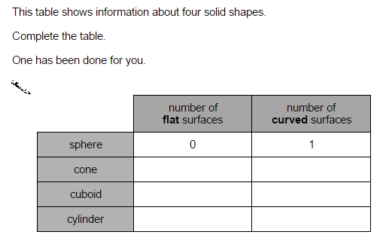
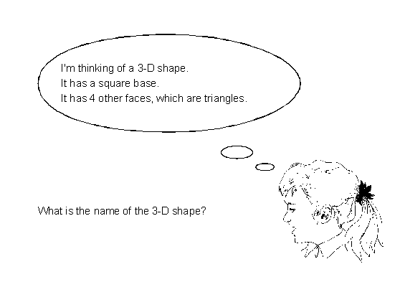
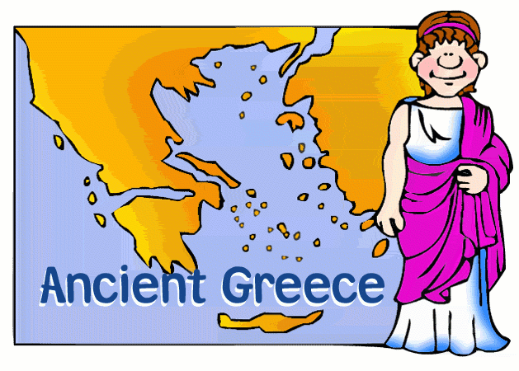
Reading Response
Next week we are looking at signifiant figures in Ancient Greece like Archimedes. Can you list the names of any other significant figures?

